**CS-GY - 9223: Cloud Computing**

# Final Project

## “ LifeStand ”

### A Fall Detection and Alert System for the sick and elderly

#### Submission by:

#### 

#### **Cheng Shi**

#### **CS5615**

#### **Rahul Manjunath Ashlesh**

#### **RMA460**

#### **Yixiu Chen**

#### **YC3691**

#### 

#### 

#### 

#### 

#### 

# Table of Contents

**Chapter 1 Introduction** **3**

**Chapter 2 User Scenarios** **3**

2.1 User falls down but recovers 3

2.2 User falls down and cannot recover 3

**Chapter 3 Architecture** **4**

**Chapter 4 API List** **4**

**Chapter 5 AWS Services used:** **5**

**Chapter 6 Fall Detection Algorithm Demo** **6**

**Chapter 7 Patient Data** **7**

**Chapter 8 Emergency Contact** **7**

**Chapter 9 Future Enhancements** **8**

# Chapter 1 Introduction

This project is an effort to implement an automated emergency service which accepts live input from webcam to analyse the status of a subject(or patent) and determine if the subject has collapsed, fallen down. On detection a set of emergency actions are triggered by the system which will de described in detail in the following sections.

# Chapter 2 User Scenarios

All users are registered and stored in the DynamoDB. For a series of users, there will be at least one family member in its vicinity who is continuously at the front end watching the camera feed and is bound to receive the alert messages and ready to help whenever a fall happens. Here are all the scenarios that could happen:

## 2.1 User falls down but recovers

The LifeStand System will monitor the patent by plotting a bounding box over the user (Referred as “patient”) and trigger an alert when the patient falls down. When the patient falls down this is detected, if the patient manages to recover and gets rid of the “Fallen” state, within the grace period (10 seconds), a confirmation message is sent to the patent’s registered mobile number and the incident is logged. the system then returns back to normal mode without sending any notifications/stress calls.

## 2.2 User falls down and cannot recover

The patient falls down and gets detected by the camera and fails to recover during the grace period (10 seconds). After the grace period, LifeStand system shifts to alert mode. A series of emergency actions are initiated:

* Send messages (notifications) to the patient’s and registered emergency contact and family member’s.
* Upon receiving the notifications, the family member has two options:
  + Directly help the patient if he/she is in the vicinity of the patient
  + Call emergency services to help the patient provided in the UI.

# Chapter 3 Architecture

#### 

The architecture will be described in detail in the following Chapters.

# Chapter 4 API List

* UserInterfaceAPI
  + UserInterfaceAPI is created by AWS API Gateway
  + UserInterfaceAPI handles requests from user(Family members) to take further steps when the fall down detection is triggered, like calling 911.
* Google Maps API
  + Google Maps API is provided by Google Maps Platform.
  + Google Maps API is used for providing location for the patient and navigation service.

# Chapter 5 AWS Services used:

* **S3:**

We use S3 Bucket to store the images of the patient captured.

* **Lambda:**

Lambda Functions are used to handle the communication and data between services

* **Kinesis:**

Kinesis Video Stream and Kinesis Data Stream are used to provide real-time video streaming of the patient via the camera.

* **DynamoDB:**

We store 3 tables in DynamoDB. They are “Matched Faces”, “Patient Data”, and “Patient State”.

* **SNS:**

SNS is responsible for sending text messages to the patient and family members.

* **API Gateway:**

API Gateway handles all the API requests (See API List above) from the front end

* **Rekognition:**

Rekognition detects the bounding box as well as the faces of the patients.

# Chapter 6 Fall Detection Algorithm Demo



We have used a Giff image as a substitute for the clickable prototype. It shows that the fall detection algorithm is detecting the person within the frame and detects a fall. We can see the real time status changing from idle to fall detected. Once we detect the fall LF2 will wait for a preset duration to check if the patent recovers, if the series of emergency actions will be initiated.

# Chapter 7 Patient Data

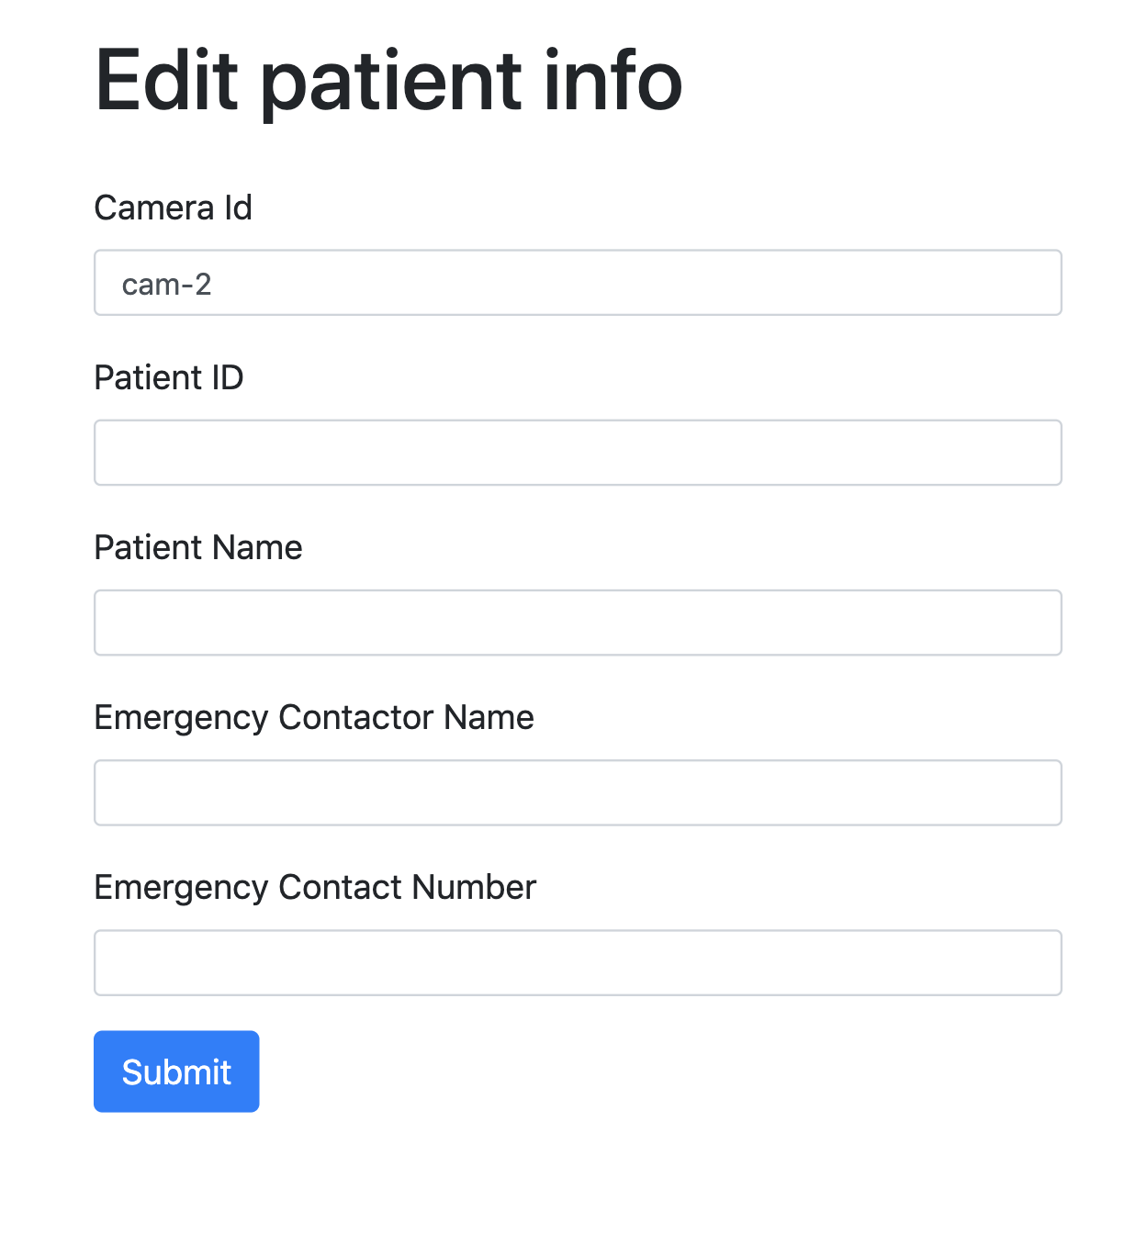

The edit patient page is used for operator to edit the patient information, including patient ID, patient name, and emergency contactor information. Each patient is paired with a camera. The selection box provides the existing cameras in the system by querying through API Gateway.

# Chapter 8 Emergency Contact

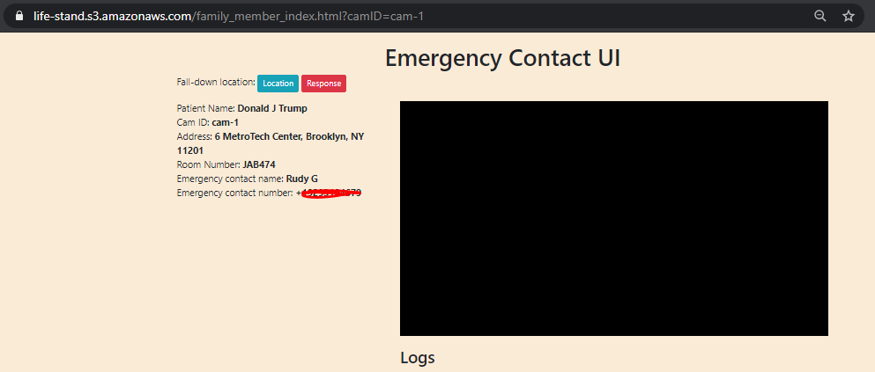

The registered emergency contact will can view a live feed of the incident and can also rewind the recording. The same can also be made available to the emergency services.

We have implemented a html live-streaming viewer extracting live video stream from KVS by using HTTP Live Streaming protocol and hls.js player. The connection between web page and KVS is established through AWS Javascript SDK.

A sample representation of the to the registered emergency contact can be found here: <https://life-stand.s3.amazonaws.com/family_member_index.html?camID=cam-1>

# Chapter 9 Future Enhancements

* Integration with AWS IOT kit such as to get a heartbeat from all active clients to keep track of the live and off the network devices.
* Image processing can be performed in the client device and only the analysis can be transmitted. This helps conserve the bandwidth but can be limited by the computation capability of the client device.
* Wearable IoT devices can be added to the profile.